JIRA PROJECT FILES

**Roadmaps for all Sprints**

TEAM ID : PNT2022TMID23095

Sprint 1

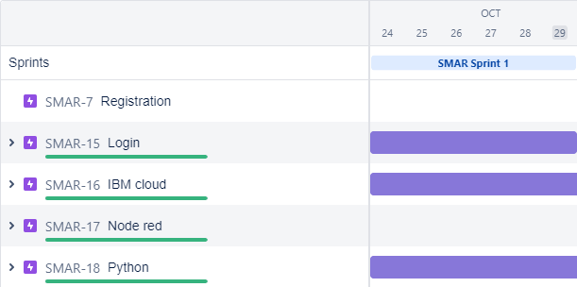

Sprint 2

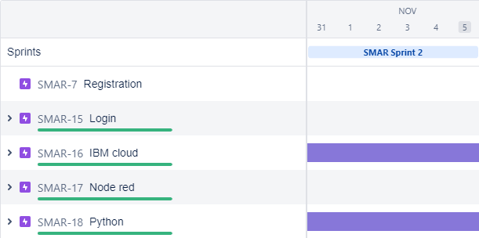

Sprint 3

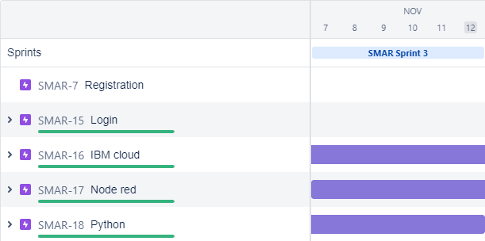

Sprint 4

